**Suppose there are 4 PCs and their default gateway is 172.16.0.254 and there is another gateway 172.61.0.253, if, due to some reason, their default gateway goes down then how those PCs will know there is another gateway and how that gateway can become automatically new default gateway. That is the role of FHRP (First Hope Redundancy Check)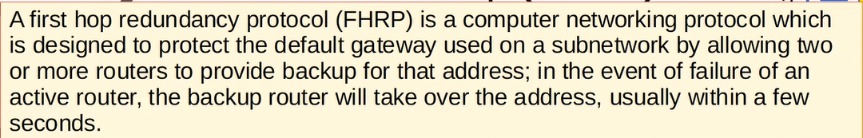How FHRP do this. Both routers will share VIP (Virtual IP) instead of the actual IPs 172.16.0.254 & 172.61.0.253 and it is configured as default gateway on PCs and the routers have to negotiate their roles with each other sending multicast ‘hello messages’ to each other, e.g., ↓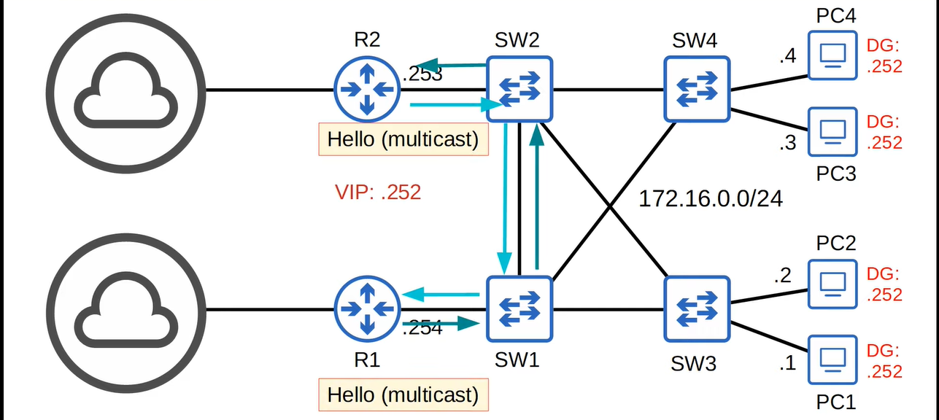the router which is currently DG is called “active” and which is for backup is called “standby” ↓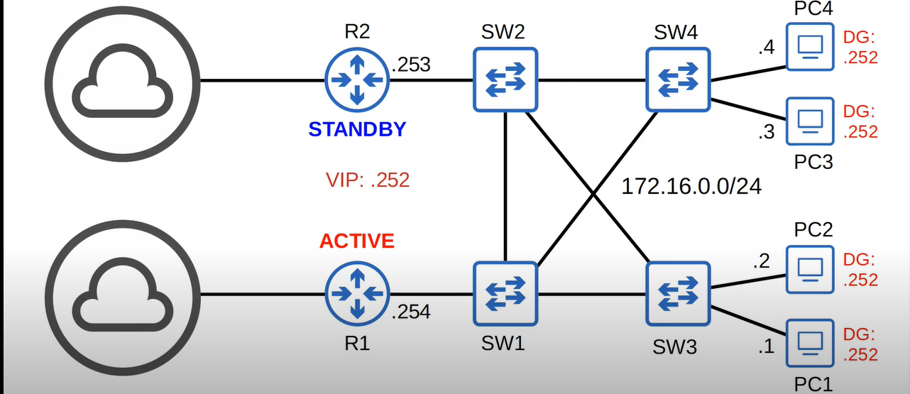Suppose PC1 wants to send some traffic to 8.8.8.8 (google server) in another network then PC1 will think ↓**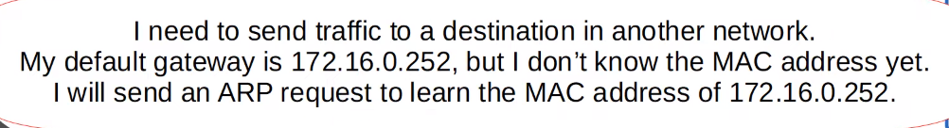

**↓**

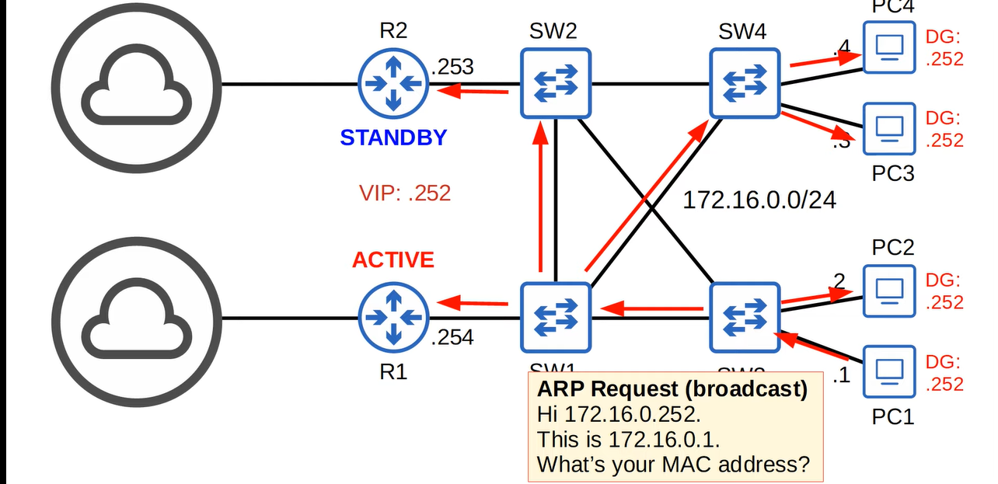**here the R1 is active, so it will send ARP-reply to PC1 ↓**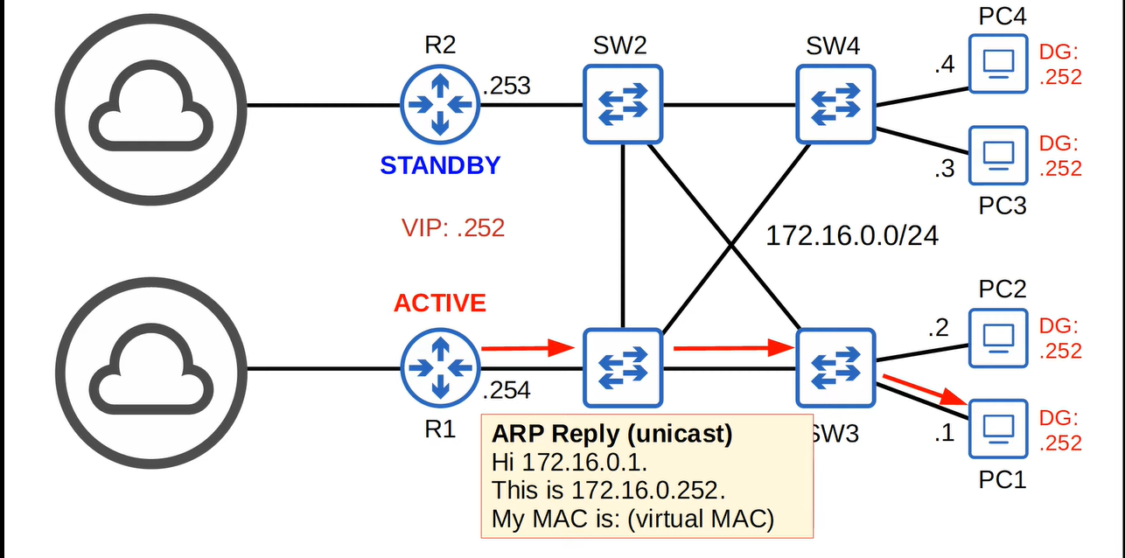

**Now ↓**

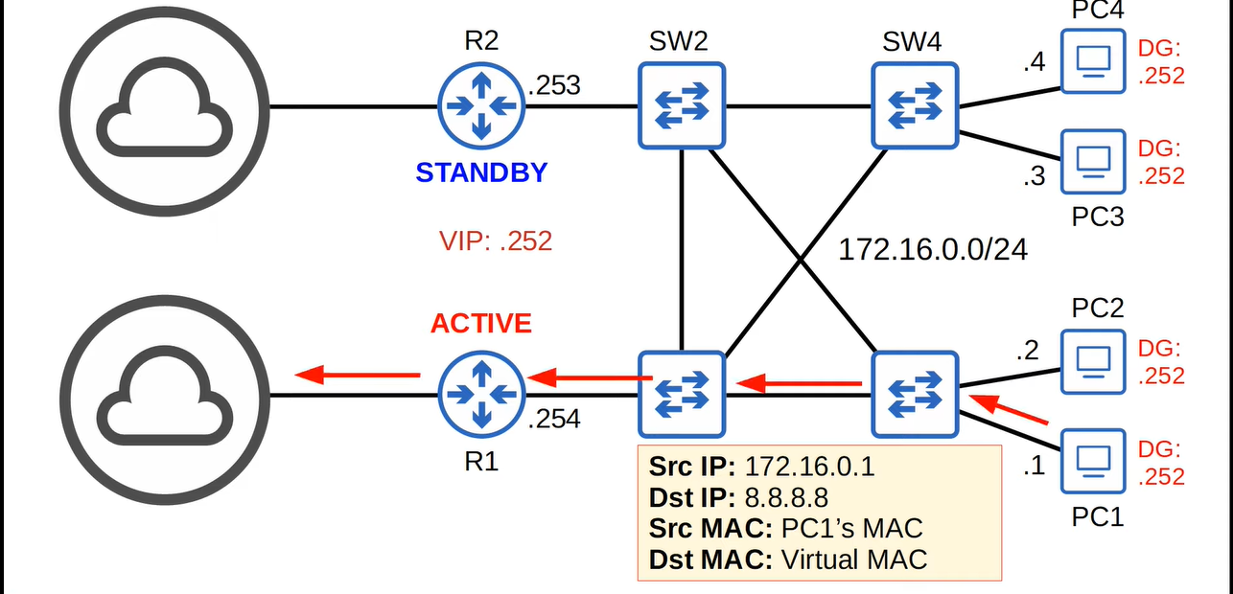**if R1 goes down then R2 will think ↓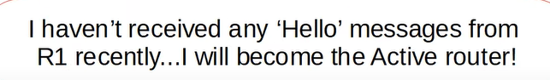 no configuration will have to be done in PCs but MAC address tables of switches will have to be updated. R2 needs to send frames with source MAC address of the virtual MAC address, so it will send “Gratuitous ARP” replies ↓**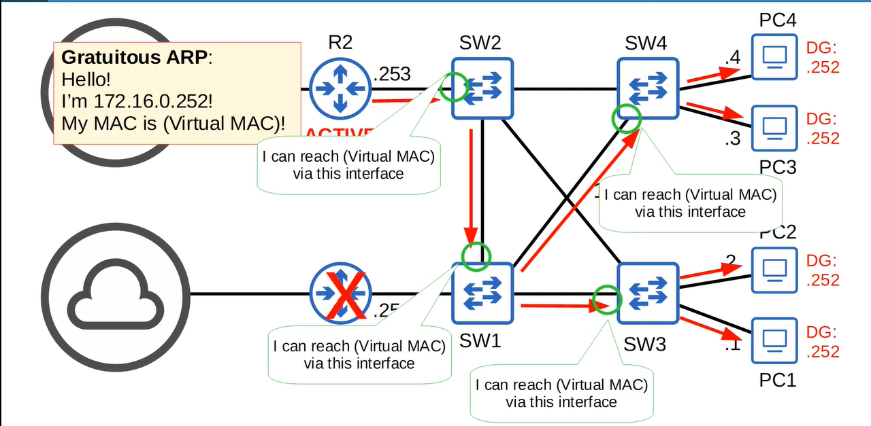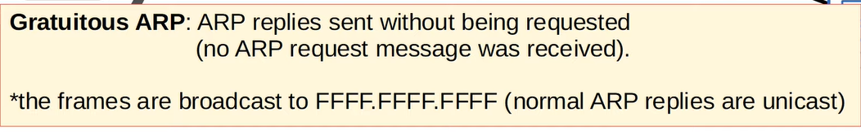

**Now if PC1 wants to send traffic to 8.8.8.8 then↓**

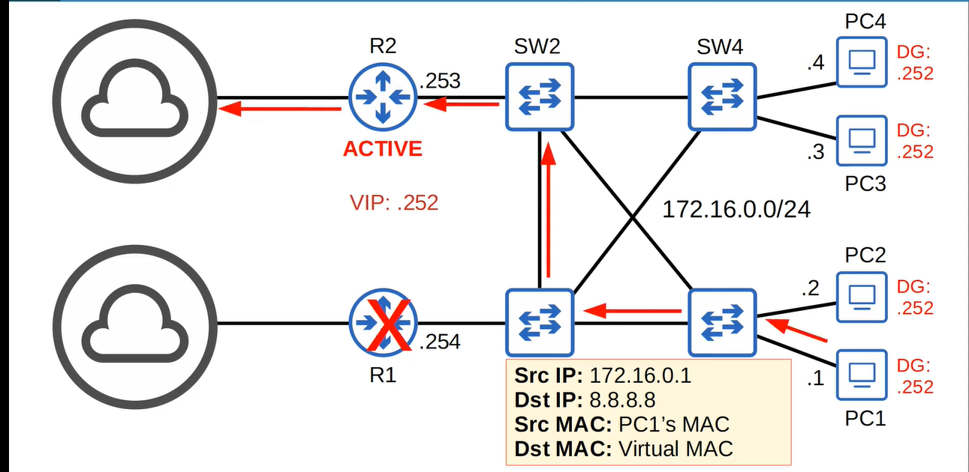**if R1 comes online again then it will become “standby” ↓**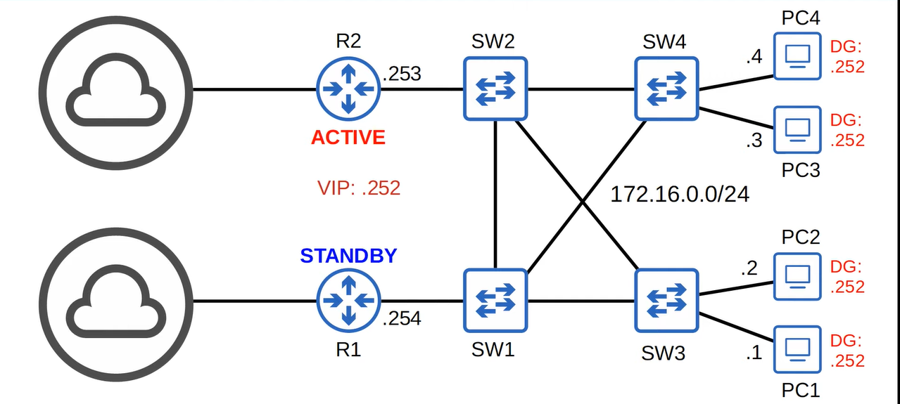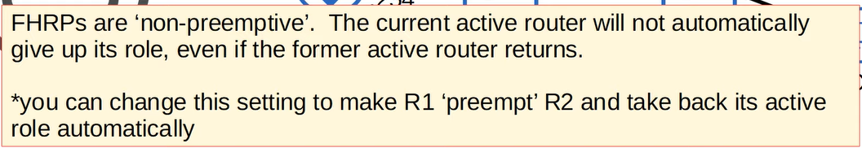

**Summary ↓**

**There are 3types of FHRP 🡪 1) HSRP 2) VRRP 3) GLBP**

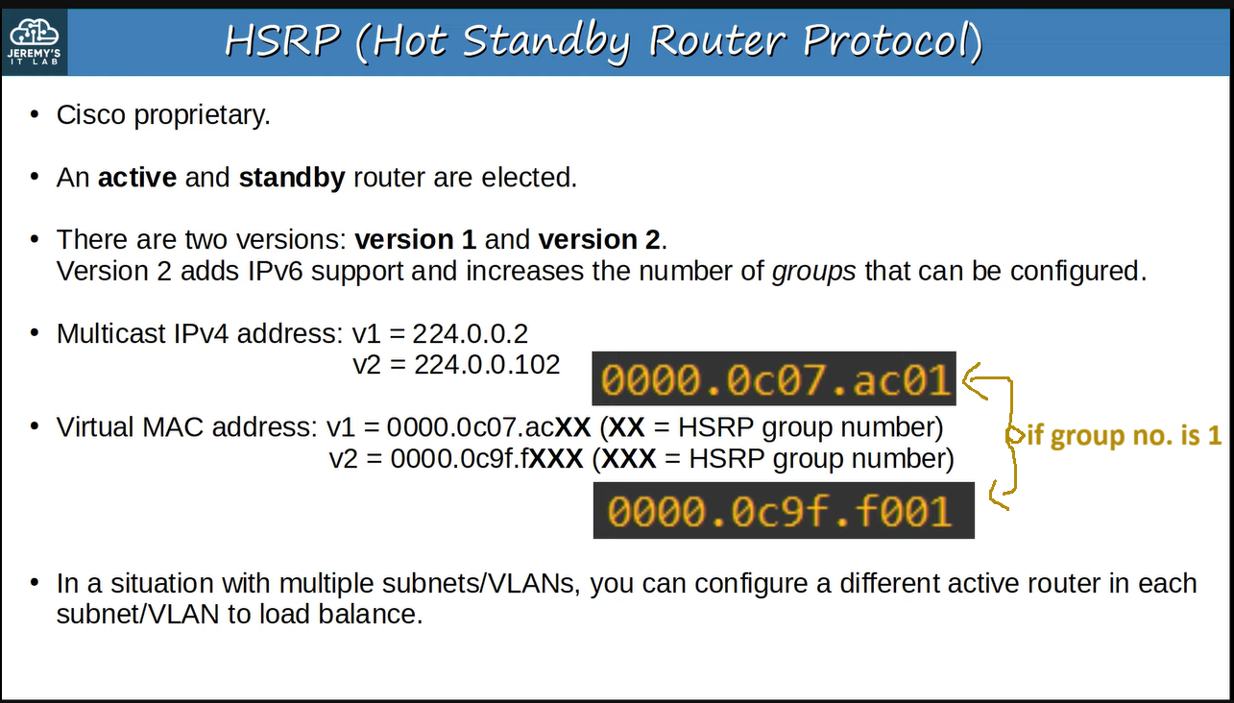**e.g., ↓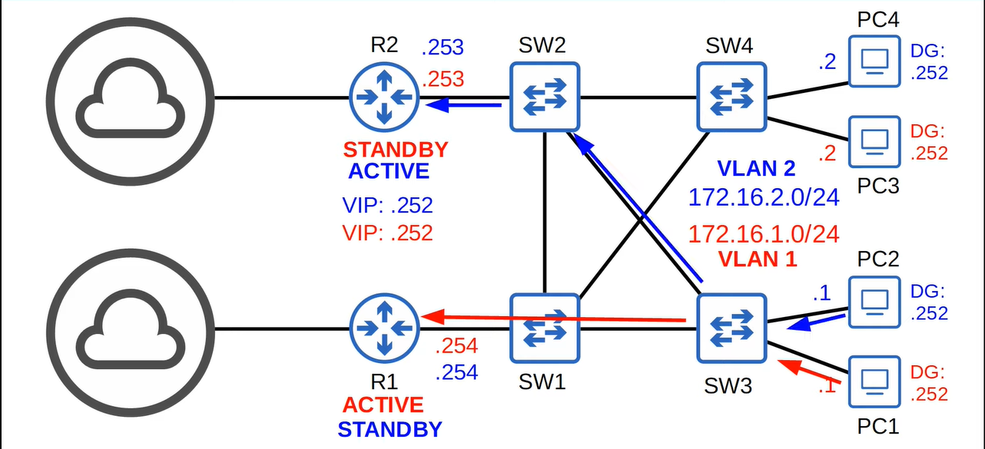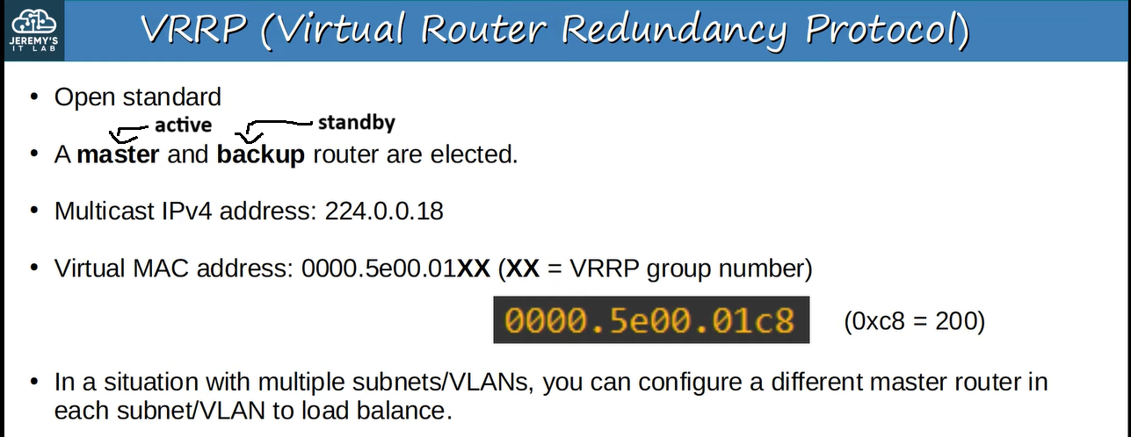e.g., ↓**

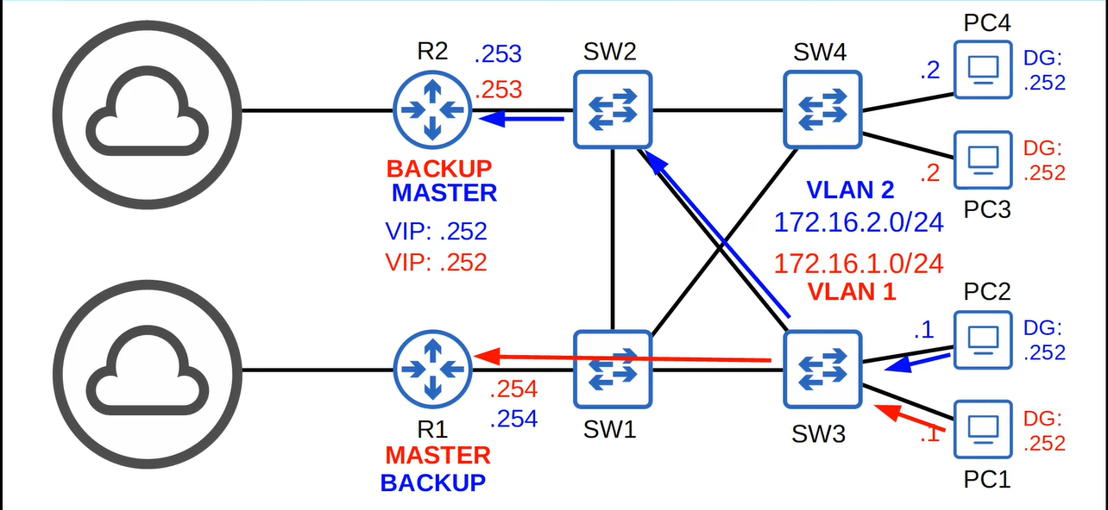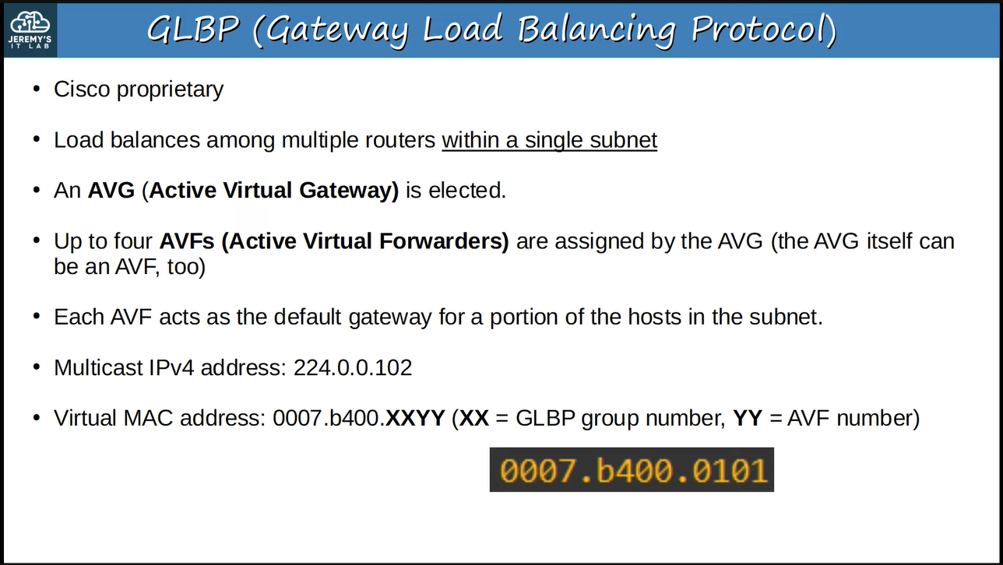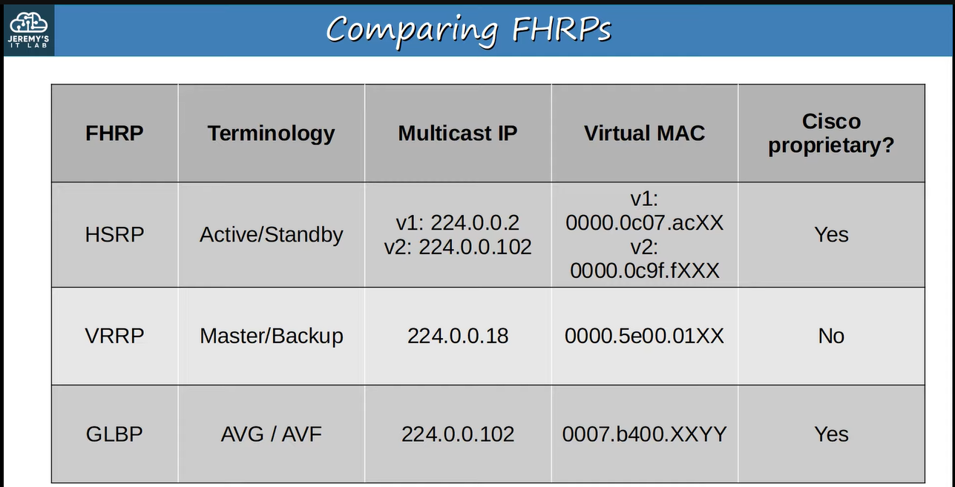

**Configuration of HSRP ↓**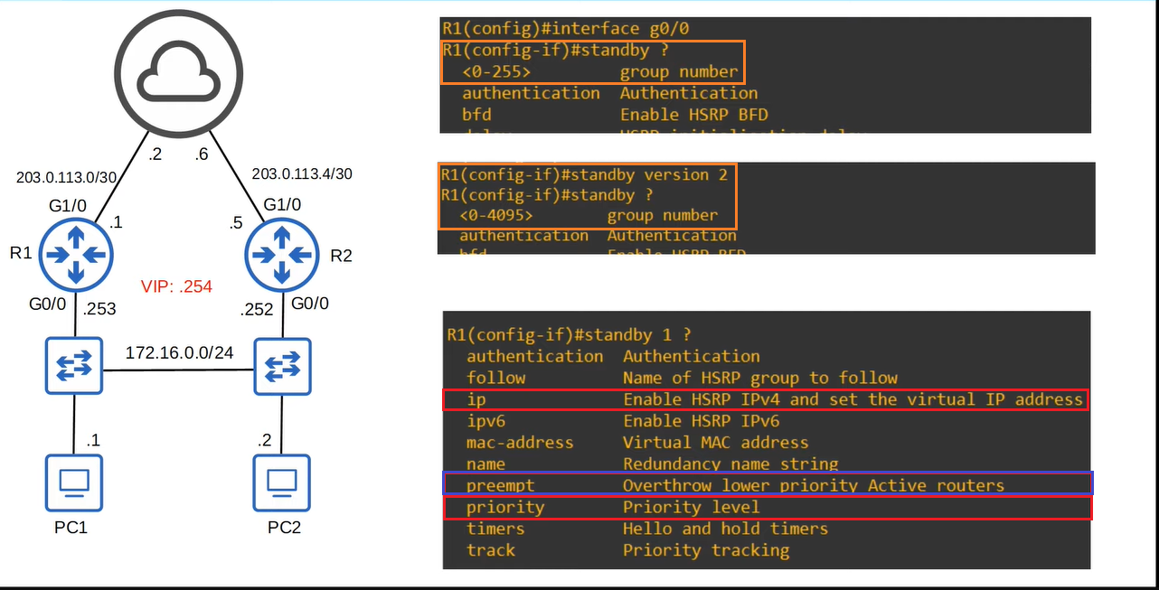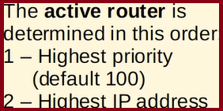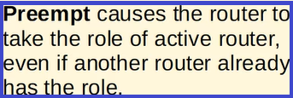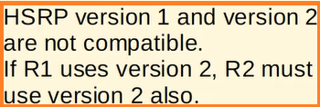

**Therefore ↓**

